Practical 10
Problem Definition
Develop secure login and logout functionality using PHP sessions. Verify password using password_verify(), regenerate session ID after login, restrict dashboard access, implement role-based redirection, session timeout, and optional secure remember-me token.
Code:-
Db.php:-
<?php
$conn = new mysqli("localhost", "root", "", "practical10_db");

if ($conn->connect_error) {
die("Database connection failed.");
}

$conn->set_charset("utf8mb4");
?>
Register.php:-
<?php
require "db.php";

$message = "";
$messageType = "";

if ($_SERVER["REQUEST_METHOD"] === "POST") {
$name = trim($_POST["name"] ?? "");
$email = filter_var(
trim($_POST["email"] ?? ""),
FILTER_VALIDATE_EMAIL
);
$password = $_POST["password"] ?? "";
$role = $_POST["role"] ?? "student";

if (
$name === "" ||
!$email ||
strlen($password) < 8 ||
!in_array($role, ["student", "admin"], true)
) {
$message = "Enter valid details. Password must be at least 8 characters.";
$messageType = "error";
} else {
$hash = password_hash($password, PASSWORD_DEFAULT);

$stmt = $conn->prepare(
"INSERT INTO users (name, email, password, role)
VALUES (?, ?, ?, ?)"
);

$stmt->bind_param("ssss", $name, $email, $hash, $role);

if ($stmt->execute()) {
$message = "Registration successful! You can now log in.";
$messageType = "success";
} else {
$message = "Registration failed. Email may already exist.";
$messageType = "error";
}

$stmt->close();
}
}
?>

<!DOCTYPE html>
<html lang="en">
<head>
<meta charset="UTF-8">
<meta name="viewport" content="width=device-width, initial-scale=1.0">
<title>StudentHub - Register</title>

<style>
* {
box-sizing: border-box;
}

body {
margin: 0;
padding: 20px;
min-height: 100vh;
font-family: Arial, sans-serif;
background: linear-gradient(135deg, #667eea, #764ba2);
display: flex;
justify-content: center;
align-items: center;
}

.register-box {
width: 100%;
max-width: 430px;
background: white;
padding: 35px;
border-radius: 15px;
box-shadow: 0 10px 30px rgba(0, 0, 0, 0.25);
}

h1 {
text-align: center;
color: #5b42b4;
margin-bottom: 8px;
}

.subtitle {
text-align: center;
color: #777;
margin-bottom: 25px;
}

.form-group {
margin-bottom: 18px;
}

label {
display: block;
margin-bottom: 7px;
font-weight: bold;
color: #333;
}

input, select {
width: 100%;
padding: 12px;
border: 1px solid #ccc;
border-radius: 7px;
font-size: 15px;
background: white;
transition: 0.3s;
}

input:focus, select:focus {
outline: none;
border-color: #667eea;
box-shadow: 0 0 6px rgba(102, 126, 234, 0.4);
}

button {
width: 100%;
padding: 13px;
background: #667eea;
color: white;
border: none;
border-radius: 7px;
font-size: 16px;
font-weight: bold;
cursor: pointer;
transition: 0.3s;
}

button:hover {
background: #4c51bf;
transform: translateY(-2px);
}

.message {
padding: 12px;
border-radius: 7px;
margin-bottom: 20px;
text-align: center;
font-size: 14px;
line-height: 1.5;
}

.success {
background: #dcfce7;
color: #166534;
}

.error {
background: #fee2e2;
color: #b91c1c;
}

.links {
text-align: center;
margin-top: 22px;
}

.links a {
color: #5b42b4;
text-decoration: none;
font-weight: bold;
}

.links a:hover {
text-decoration: underline;
}

@media (max-width: 480px) {
.register-box {
padding: 25px 20px;
}

h1 {
font-size: 25px;
}
}
</style>
</head>

<body>

<div class="register-box">

<h1>StudentHub</h1>
<p class="subtitle">Create Your Account</p>

<?php if ($message !== ""): ?>
<div class="message <?= htmlspecialchars($messageType) ?>">
<?= htmlspecialchars($message) ?>
</div>
<?php endif; ?>

<form method="POST" action="register.php">

<div class="form-group">
<label for="name">Full Name</label>
<input
type="text"
id="name"
name="name"
placeholder="Enter your full name"
maxlength="100"
required
>
</div>

<div class="form-group">
<label for="email">Email Address</label>
<input
type="email"
id="email"
name="email"
placeholder="Enter your email"
maxlength="150"
required
>
</div>

<div class="form-group">
<label for="password">Password</label>
<input
type="password"
id="password"
name="password"
placeholder="Minimum 8 characters"
minlength="8"
required
>
</div>

<div class="form-group">
<label for="role">Select Role</label>
<select id="role" name="role" required>
<option value="student">Student</option>
<option value="admin">Admin</option>
</select>
</div>

<button type="submit">Register Now</button>

</form>

<div class="links">
<p>Already have an account?</p>
<a href="login.php">Login Here</a>
<p><a href="index.html">Back to Home</a></p>
</div>

</div>

</body>
</html>
Admin.php:-
<?php
session_start();

$timeout = 900;

if (!isset($_SESSION["user_id"])) {
header("Location: login.php");
exit;
}

if (
!isset($_SESSION["last_activity"]) ||
time() - $_SESSION["last_activity"] >= $timeout
) {
$_SESSION = [];
session_destroy();

header("Location: login.php?timeout=1");
exit;
}

if ($_SESSION["role"] !== "admin") {
header("Location: dashboard.php");
exit;
}

$_SESSION["last_activity"] = time();
?>

<!DOCTYPE html>
<html lang="en">
<head>
<meta charset="UTF-8">
<title>Admin Panel</title>
</head>
<body>
<h1>Admin Panel</h1>

<h3>
Welcome, <?= htmlspecialchars($_SESSION["name"]) ?>!
</h3>

<p>Only administrators can access this page.</p>

<a href="logout.php">Logout</a>
</body>
</html>
Login.php:-
<?php
ini_set("session.use_strict_mode", "1");

session_set_cookie_params([
"httponly" => true,
"secure" => !empty($_SERVER["HTTPS"]) &&
$_SERVER["HTTPS"] !== "off",
"samesite" => "Lax",
"path" => "/"
]);

session_start();
require "db.php";

$error = "";

if ($_SERVER["REQUEST_METHOD"] === "POST") {
$email = trim($_POST["email"] ?? "");
$password = $_POST["password"] ?? "";

$stmt = $conn->prepare(
"SELECT id, name, email, password, role
FROM users WHERE email = ?"
);

$stmt->bind_param("s", $email);
$stmt->execute();

$result = $stmt->get_result();
$user = $result->fetch_assoc();
$stmt->close();

if ($user && password_verify($password, $user["password"])) {
session_regenerate_id(true);

$_SESSION["user_id"] = $user["id"];
$_SESSION["name"] = $user["name"];
$_SESSION["role"] = $user["role"];
$_SESSION["last_activity"] = time();

if ($user["role"] === "admin") {
header("Location: admin.php");
} else {
header("Location: dashboard.php");
}
exit;
} else {
$error = "Invalid email or password!";
}
}
?>

<!DOCTYPE html>
<html lang="en">
<head>
<meta charset="UTF-8">
<meta name="viewport" content="width=device-width, initial-scale=1.0">
<title>StudentHub - Secure Login</title>

<style>
* {
box-sizing: border-box;
}

body {
margin: 0;
font-family: Arial, sans-serif;
background: linear-gradient(135deg, #667eea, #764ba2);
min-height: 100vh;
display: flex;
justify-content: center;
align-items: center;
padding: 20px;
}

.login-box {
background: white;
width: 100%;
max-width: 400px;
padding: 35px;
border-radius: 15px;
box-shadow: 0 10px 30px rgba(0, 0, 0, 0.25);
text-align: center;
}

.login-box h1 {
color: #5b42b4;
margin-bottom: 8px;
font-size: 28px;
}

.subtitle {
color: #777;
margin-bottom: 25px;
}

.input-group {
text-align: left;
margin-bottom: 18px;
}

.input-group label {
display: block;
margin-bottom: 7px;
font-weight: bold;
color: #333;
}

.input-group input {
width: 100%;
padding: 12px;
border: 1px solid #ccc;
border-radius: 7px;
font-size: 15px;
transition: 0.3s;
}

.input-group input:focus {
outline: none;
border-color: #667eea;
box-shadow: 0 0 6px rgba(102, 126, 234, 0.4);
}

.remember {
display: flex;
align-items: center;
gap: 8px;
margin-bottom: 20px;
text-align: left;
font-size: 14px;
color: #444;
}

.remember input {
accent-color: #667eea;
}

.login-btn {
width: 100%;
padding: 13px;
border: none;
border-radius: 7px;
background: #667eea;
color: white;
font-size: 16px;
font-weight: bold;
cursor: pointer;
transition: 0.3s;
}

.login-btn:hover {
background: #4c51bf;
transform: translateY(-2px);
}

.error {
background: #ffe5e5;
color: #c62828;
padding: 10px;
border-radius: 6px;
margin-bottom: 18px;
font-size: 14px;
}

.message {
color: #b45309;
background: #fef3c7;
padding: 10px;
border-radius: 6px;
margin-bottom: 18px;
font-size: 14px;
}

.links {
margin-top: 22px;
font-size: 14px;
}

.links a {
color: #5b42b4;
text-decoration: none;
font-weight: bold;
}

.links a:hover {
text-decoration: underline;
}

@media (max-width: 480px) {
.login-box {
padding: 25px 20px;
}

.login-box h1 {
font-size: 24px;
}
}
</style>
</head>

<body>

<div class="login-box">

<h1>StudentHub</h1>
<p class="subtitle">Login to your account</p>

<?php if ($error !== ""): ?>
<div class="error">
<?= htmlspecialchars($error) ?>
</div>
<?php endif; ?>

<?php if (isset($_GET["timeout"])): ?>
<div class="message">
Your session expired. Please log in again.
</div>
<?php endif; ?>

<form method="POST" action="login.php">

<div class="input-group">
<label for="email">Email Address</label>
<input
type="email"
id="email"
name="email"
placeholder="Enter your email"
autocomplete="username"
required
>
</div>

<div class="input-group">
<label for="password">Password</label>
<input
type="password"
id="password"
name="password"
placeholder="Enter your password"
autocomplete="current-password"
required
>
</div>

<label class="remember">
<input type="checkbox" name="remember" value="1">
Remember Me
</label>

<button type="submit" class="login-btn">
Login
</button>

</form>

<div class="links">
<p><a href="register.php">Create an Account</a></p>
<p><a href="index.html">Back to Home</a></p>
</div>

</div>

</body>
</html>
Screenshot:-
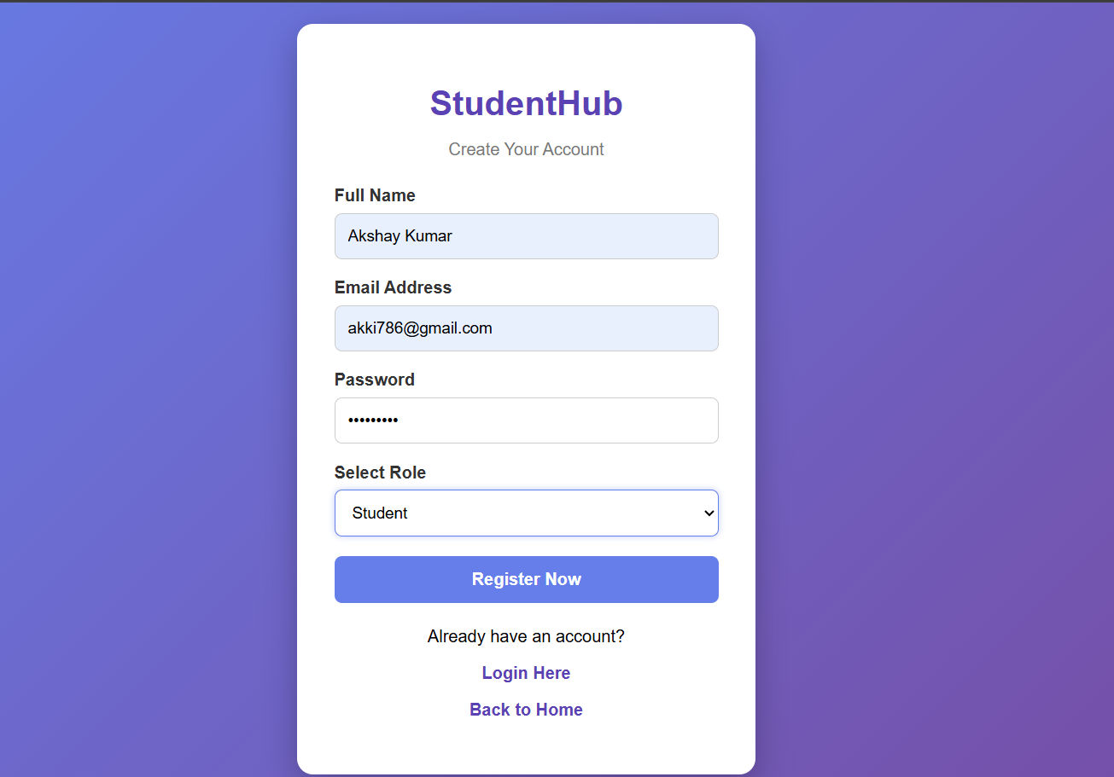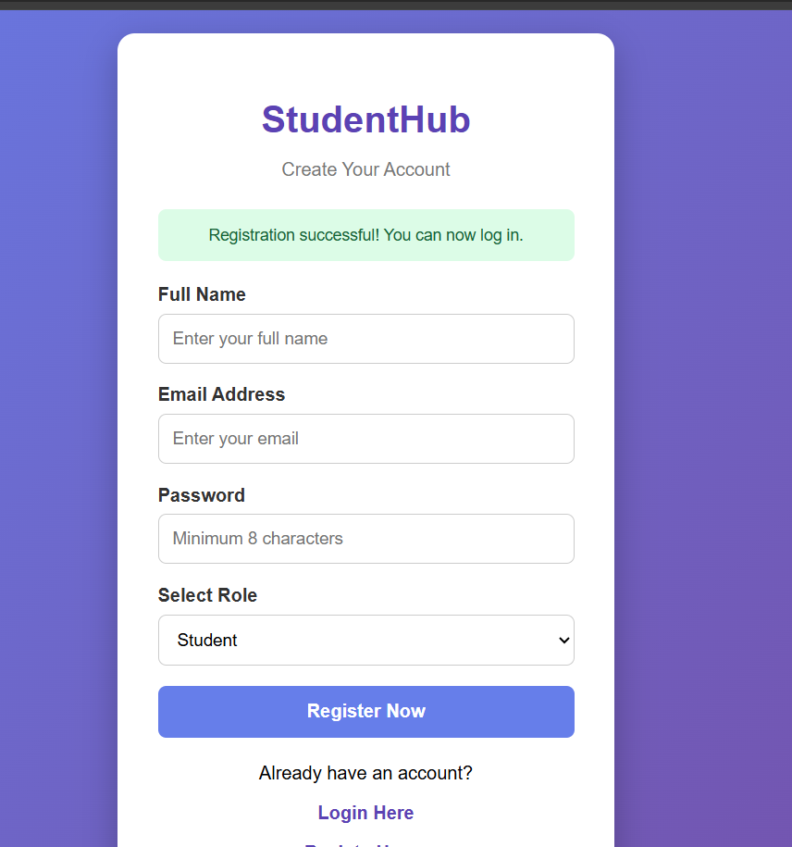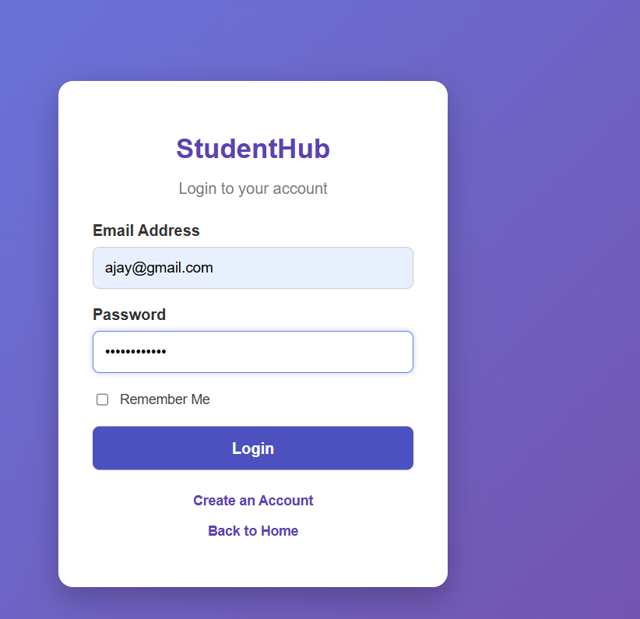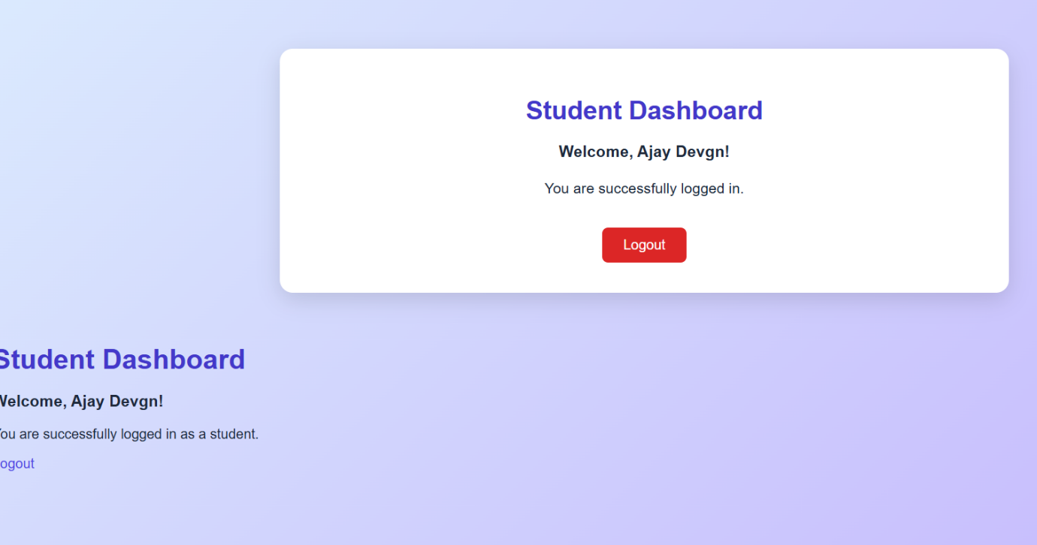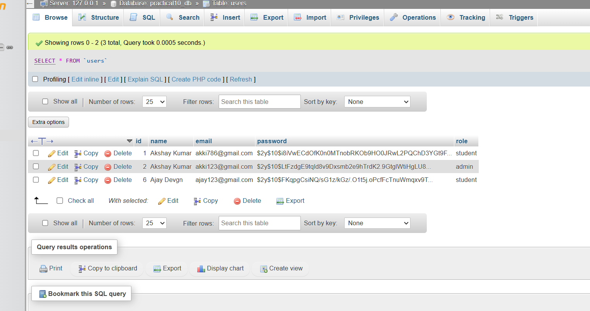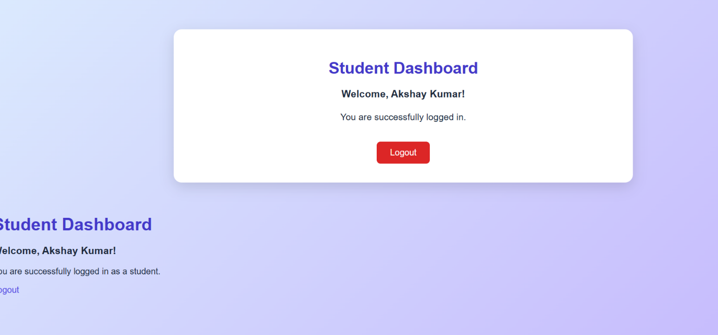
Key Questions:-
1. Are sessions started and destroyed securely?
Yes. session_start() starts the session, and session_regenerate_id(true) generates a new session ID after successful login. In logout.php, session_destroy() destroys the session.
2. Is password_verify() used correctly?
Yes. The password_verify() function compares the entered password with the hashed password stored in the database. Passwords are hashed using password_hash() during registration.
3. Is unauthorized dashboard access blocked?
Yes. The dashboard checks whether the user is logged in. If not, the user is redirected to login.php. Role checks prevent students from accessing the admin panel.
4. Is session timeout implemented?
Yes. A session timeout of 15 minutes (900 seconds) is implemented. If the user is inactive for 15 minutes, the session is destroyed and the user is redirected to the login page.
5. Are admin and student users redirected to appropriate dashboards?
Yes. After successful login, admin users are redirected to admin.php, while student users are redirected to dashboard.php, based on their roles stored in the database.

